Lesson 12 -Answer business questions

If you went through the lesson on Eniac’s strategy, you should remember that the company has two main concerns. In summary:

* Is Magist a good fit for high-end tech products?
* Are orders delivered on time?

Additionally to these big concerns, your manager has sent you a list of more concrete questions coming from different members of the company. For some of these questions, you will need to combine columns of different tables. If you still a little unsure about JOINs, it might be a good idea to follow this lesson:

[Combining Tables with SQL](https://www.codecademy.com/courses/learn-sql/lessons/multiple-tables/exercises/intro)

[Learn about different join types and practice your syntax.](https://www.codecademy.com/courses/learn-sql/lessons/multiple-tables/exercises/intro)

[Go to course](https://www.codecademy.com/courses/learn-sql/lessons/multiple-tables/exercises/intro)

**Prepare MySQL Workbench for heavy lifting**

Many programs that run tasks that can be computationally expensive have “timeouts”: an interval of time after which a task is cancelled if it has not been completed. Timeouts are useful when there is a risk that the programmer mistakenly runs an infinite loop or a task that’s too large, as they could risk hardware overheating, or just an unnecessary loss of time. MySQL Workbench has, by default, a 30 seconds “read timeout interval”. This is a bit too strict for some of the tasks you might have to run: joining large tables takes time, especially if your laptop doesn’t have a fast CPU. We recommend increasing it to 300 or 600 seconds to prevent some queries from being crushed by the timeout.

To do so, go to the Workbench Preferences (on Windows, Edit > Preferences; on Mac, MySQLWorkbench > Preferences), then select “SQL Editor” on the left menu, and change the timeout value as shown below.

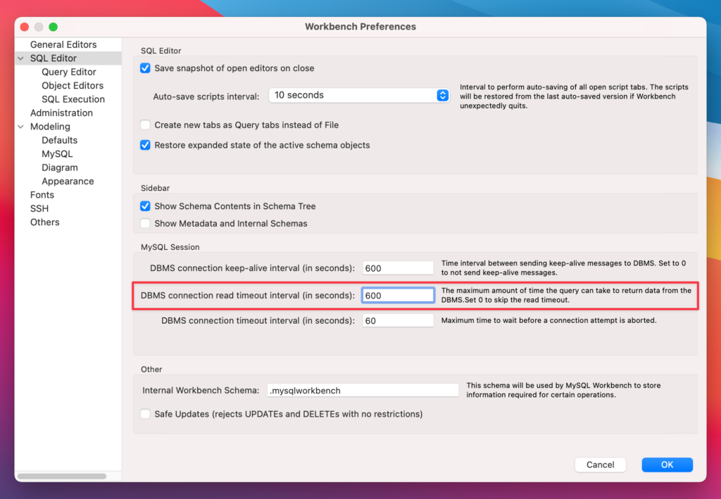

Business questions

Whenever you feel ready for it, go through the questions below. Note that in many cases, you will have to translate business terms into tables, columns and aggregations. Whenever needed, make your own educated guesses or assumptions (e.g. what can be considered a “tech” or an “expensive” product).

**In relation to the products:**

* What categories of tech products does Magist have?
* How many products of these tech categories have been sold (within the time window of the database snapshot)? What percentage does that represent from the overall number of products sold?
* What’s the average price of the products being sold?
* Are expensive tech products popular? *

* TIP: Look at [the function CASE WHEN](https://www.w3schools.com/sql/sql_case.asp) to accomplish this task.

**In relation to the sellers:**

* How many months of data are included in the magist database?
* How many sellers are there? How many Tech sellers are there? What percentage of overall sellers are Tech sellers?
* What is the total amount earned by all sellers? What is the total amount earned by all Tech sellers?
  + Can you work out the average monthly income of all sellers? Can you work out the average monthly income of Tech sellers?

**In relation to the delivery time:**

* What’s the average time between the order being placed and the product being delivered?
* How many orders are delivered on time vs orders delivered with a delay?
* Is there any pattern for delayed orders, e.g. big products being delayed more often?